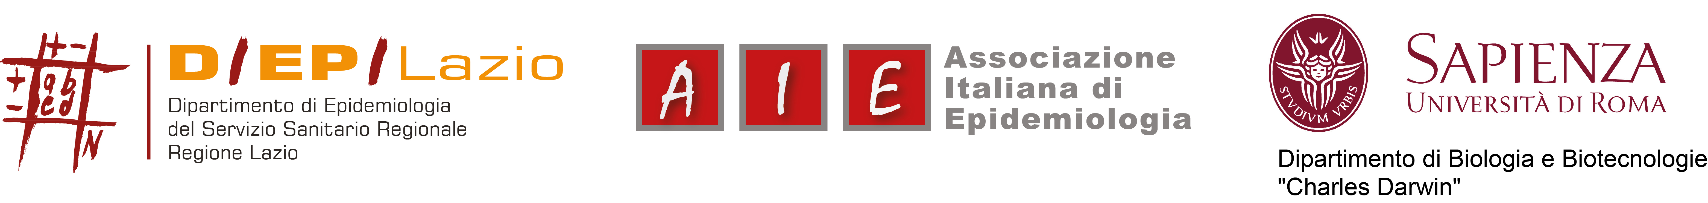

Registration form
Causal Inference in Epidemiology and application to Environmental Health
(course leader: Massimo Stafoggia)
July, 13-17 2015
Aula Montalenti, Dipartimento di Biologia e Biotecnologie Charles Darwin (BBCD), Edificio “Genetica”
La Sapienza Università di Roma
Viale Regina Elena 295 – Roma
Participant
Participant Name & Surname
Organization Name
Organization Address
Contact Details | Phone: | Fax:
 | e-mail:
Registration
Registration form should be sent to Patrizia Compagnucci (p.compagnucci@deplazio.it) before July 3rd, 2015.
Applications will be accepted in chronological order subject to availability on a first come first admitted basis.
AVAILABLE PLACES: 30
A confirmation e-mail will be sent.

payment
The payment of the participation fee must be paid up to a day before the start of the course by bank transfer to:
Associazione Italiana di Epidemiologia
Bank: Unipol Ag. Piazza Wagner 8, Milano
IBAN: IT 61 Y 03127 01600 000000003797
Please specify: name of participant(s) and submission “Course Causal Inference in Epidemiology and application to Environmental Health”

Please send bank receipt by fax (+39 06 83060336) or by e-mail (p.compagnucci@deplazio.it) up to a day before the start of the course.

Cancellation shall be notified no later than the seventh working day (including Saturday) before the start of the course. After that date we will keep the full fee. We accept a colleague as a replace, upon notice by e-mail (p.compagnucci@deplazio.it) two days before the course date.

